**Standard Operating Procedure**

**Approving AMEX Card Application on @Work**

Document History

Document Location

This is an on-line document. Paper copies are valid only on the day they are printed. Refer to the Genpact approver for location where last version of the document is stored or if you are in any doubt about the accuracy of this document.

Document Creation

|  |  |  |
| --- | --- | --- |
| Creation Date: | Genpact approval by: | Customer approval by: |
| 7 JUL 16 | Syed Ahsan Kamal | Raquel Carbonell |

Revision History

|  |  |  |  |  |  |
| --- | --- | --- | --- | --- | --- |
| Revision Date: | Version Number: | Change reason: | Pages Changed (pg. no.) | Genpact approval by: | Customer approval by: |
| June 25,2019 |  | Process Update | 5 | Syed Ahsan Kamal |  |
|  |  |  |  |  |  |
|  |  |  |  |  |  |
|  |  |  |  |  |  |
|  |  |  |  |  |  |
|  |  |  |  |  |  |
|  |  |  |  |  |  |
|  |  |  |  |  |  |
|  |  |  |  |  |  |

Table of Contents

1. Overview 4

1.1. Customer Overview 4

1.2. Purpose 4

1.3. Scope 4

1.4. Definitions 4

1.5. System Overview 5

1.6. Roles and Responsibilities 5

2. Process Narrative 5

3. Detailed Process Steps 6

3.1. Review Card Application - Step 1 9

3.2. Review Card Application - Step 2 11

4. Compliance Control 13

5. Escalation Process 13

6. Contact details for T&E 13

7.  **Process SLAs** 14

8. Sign Off. 14

1. Overview
   1. Customer Overview

McGraw-Hill is a content, software and services-based education company that offer solutions for pre-Kindergarten through postgraduate education. The company also provides reference & trade publications for the medical, business and engineering professions.

Divisions of McGraw-Hill include:

* McGraw-Hill Higher Education
* McGraw-Hill International
* McGraw-Hill Professional
* McGraw-Hill School Education
  1. Purpose

The purpose of the document is to understand the step by step process to approve both T/P-Card applications online on AMEX@Work.

* 1. Scope

Approve online T/P-Card application request using AmEx@Work once the employee’s manager provides approval through email. Below is the example email conversation.



* 1. Definitions

|  |  |
| --- | --- |
| Abbreviation: | Long Form: |
| T&E | Travel and Entertainment |
| AMEX | American Express |
| T-Card | Travel Card |
| P-Card | Purchase Card |

* 1. System Overview

AmEx@Work website is used to approve the on-line submitted application. We will use Oracle to verify the employee details. If the employee has provided their correct details in application or not.

We will verify if the employee EIN number, SSN and their manager name is correctly mentioned on the application or not.

* 1. Roles and Responsibilities

|  |  |
| --- | --- |
| Role: | Responsibility: |
| T&E Analyst | Approve card application request on AmEx@Work once approved by the employee’s manager |
|  |  |
|  |  |

1. Process Narrative

To get a T/P-Card, the employee needs to submit online application through Spark. The website link can be found in Spark below.

https://spark.mheducation.com/docs/DOC-152066

The employee needs to mention their manager email in approvers tab, then once the application is submitted, an automatic trigger goes to employee’s manager to provide approval through email.

Once the manager approves, T&E analyst will go to the AmEx@Work to verify the application. Oracle database will be used to verify the employee’s detail, if the employee has provided correct EIN, SSN and Manager’s email address.

If the above details are correct, then we will approve the application and submit it. Once the application is submitted in AmEx, we will get a tracking number to track the application. In 7-10 business days, the employee’s card will reach to their relevant address. If the employee needs the card urgently and choose the RUSH option, the employee will receive the card within 2 to 3 business days.

P-Card limit should be specified in the application form or via an email to MHE T&E help desk, if not the default limit will be given of $25k per transaction and $100k per month.

1. Detailed Process Steps

Approving AmEx Card Application on AmEx@Work.

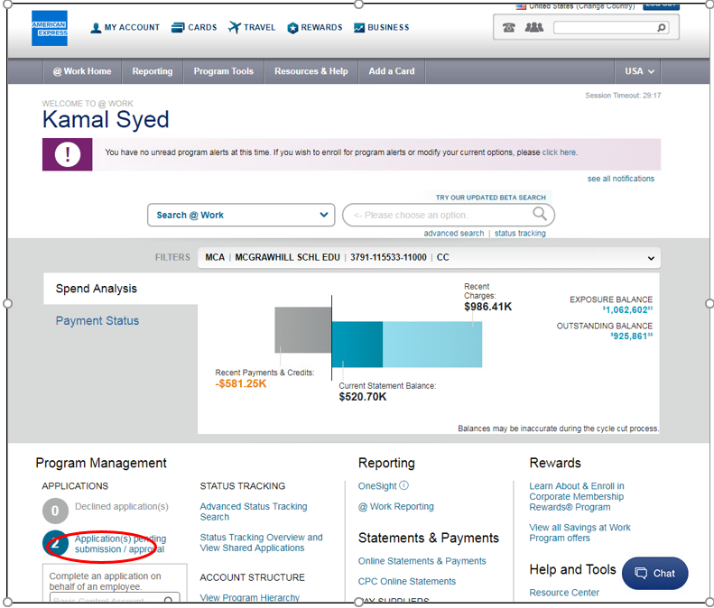

1. The above screenshot is a homepage of AmEx@Work. On the left hand side of the screen, we will find the number of applications pending in for approval.

We need to click on the link, which states the number of application that requires your submission or approval. Once we click on the link, we get the list of number of application for approval.

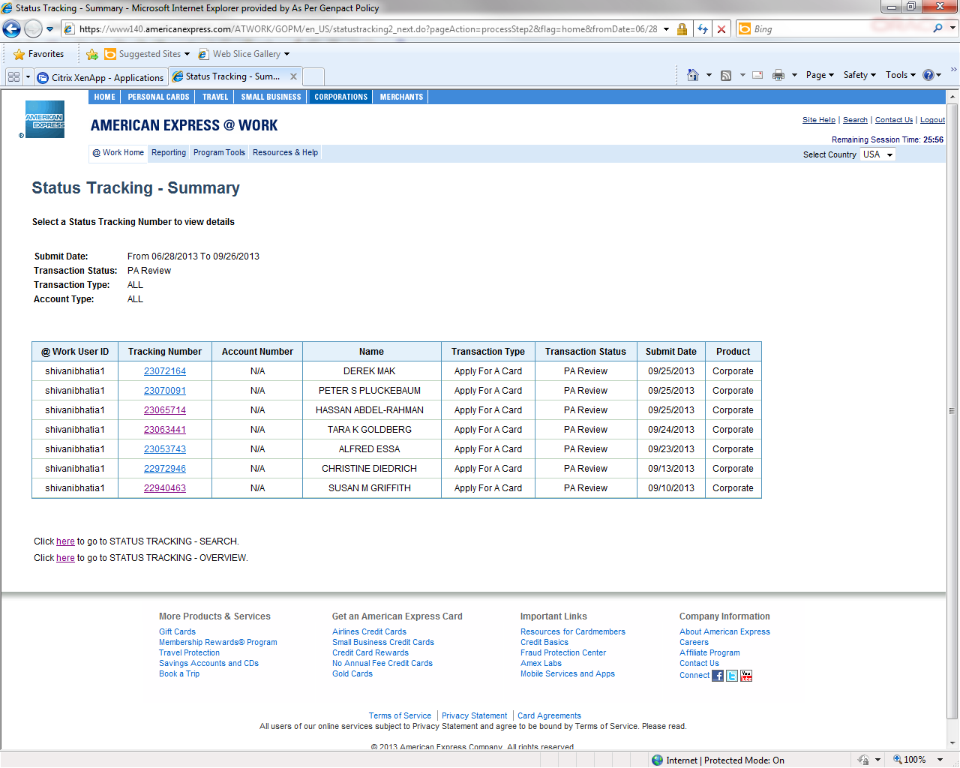

1. The above screenshot shows number of applications which need to be approved.

To approve the application for individual employee, you need to click on the tracking number.

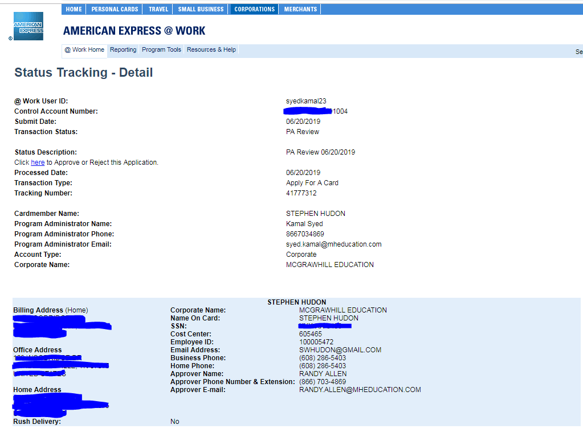

1. Once we click the tracking number, we will be able to view the details provided by the employee in the card application.
2. Name of the employee
3. Employee ID
4. SSN
5. Email Address
6. Home Phone
7. Approver E-mail
8. To continue to approve or reject the application, we need to click on the link under “Status Description”
   1. Review Card Application - Step 1

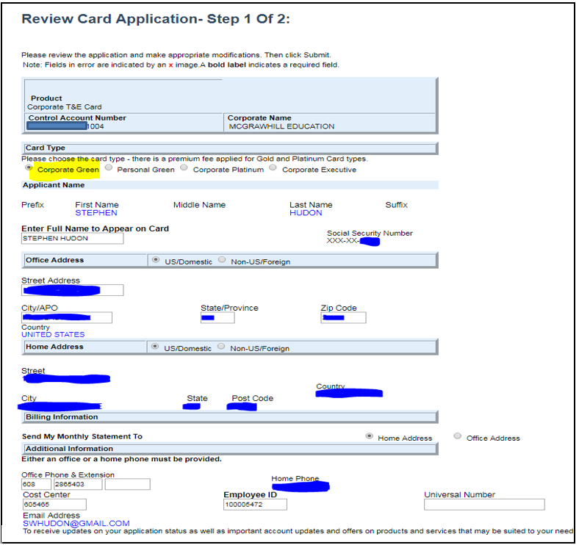

1. In review of the card application, you can change details provided by the employee if needed.
2. The details which can be updated are the employees address, office phone, extension, employee ID and cost center.

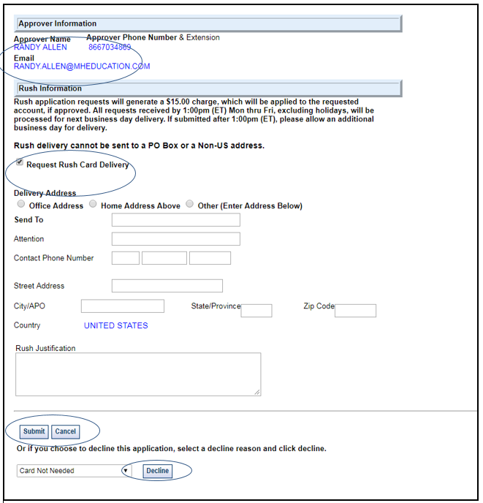

1. In the above screenshot, we can see the approver’s name, email, and phone number.
2. We have an option for RUSH delivery which will escalate delivery of card to 2-3business days. If the employee wants to process the card application with Rush delivery, then we need to fill the above Information fields (address and reason for rush delivery). Please note, this service provided by AmEx is associated with a $15 fee.
3. Once we get the approval confirmation from employee’s manager, we can now submit the application by clicking on the “Submit tab” or “Decline” the card if required by selecting the option reason for rejecting the card. Below is the sample email approval for reference.

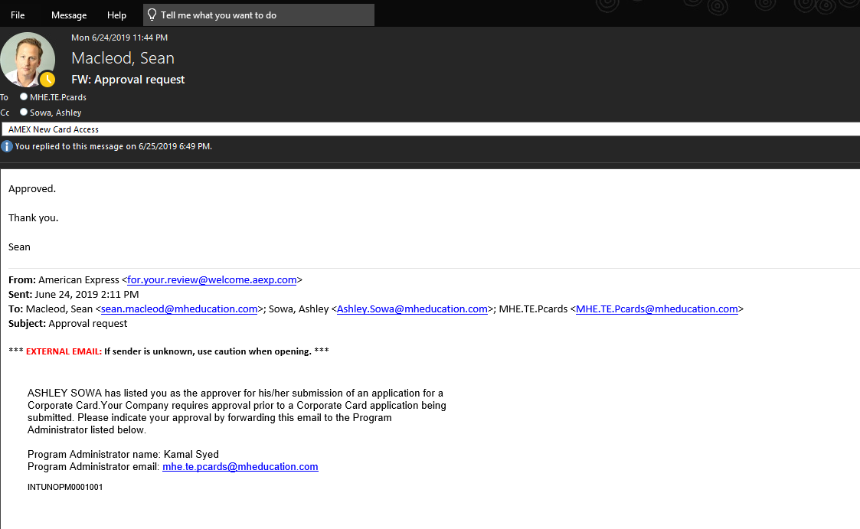

* 1. Review Card Application - Step 2

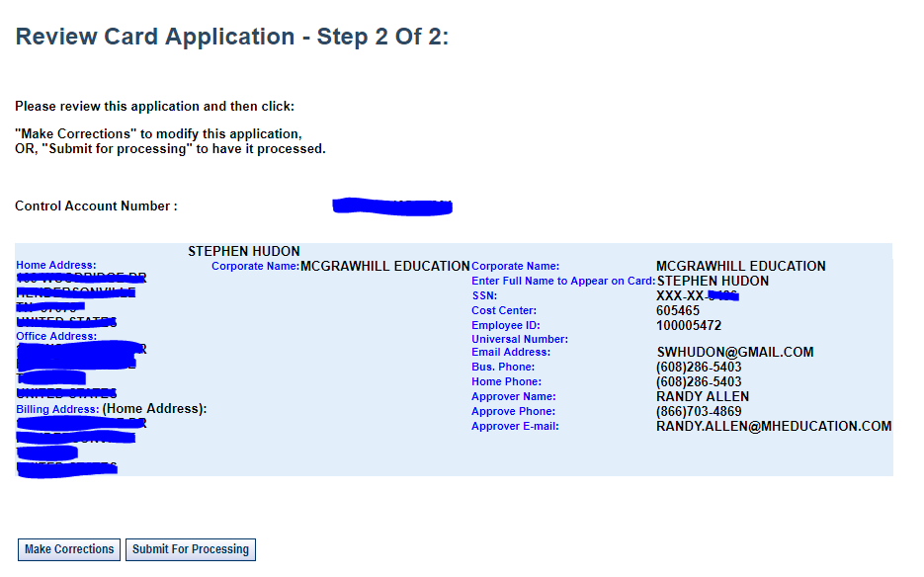

1. Once the application is reviewed click on “Submit for processing”.

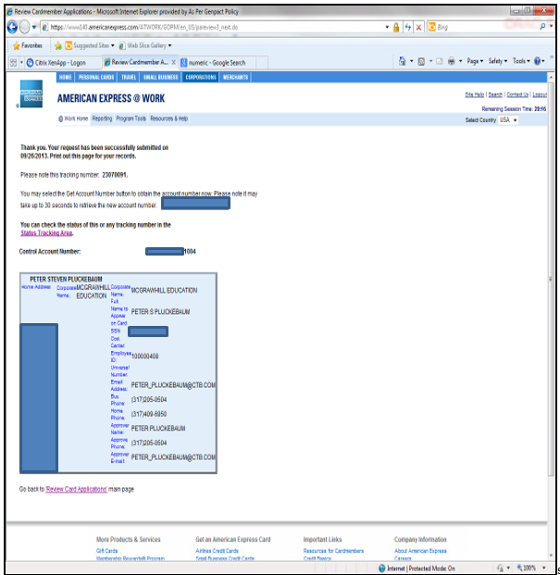

1. In the above screenshot, it will show the card application is successfully approved and submitted. You will also find “tracking number” to trace the application. The card will ideally reach to the given address in 7-10 business days. A Rush delivery is within 2 to 3 business days.
2. Same procedure for processing P-Card application, just we need to enter Monthly and Transaction limits while processing P-Card application, if no limits are provided on the form, the T&E team needs to enter default limits.

**The Default approval limits for P-Card as below:**

**Monthly Limit $100,000**

**Transaction Limit $25,000**

Below is the screenshot for reference:

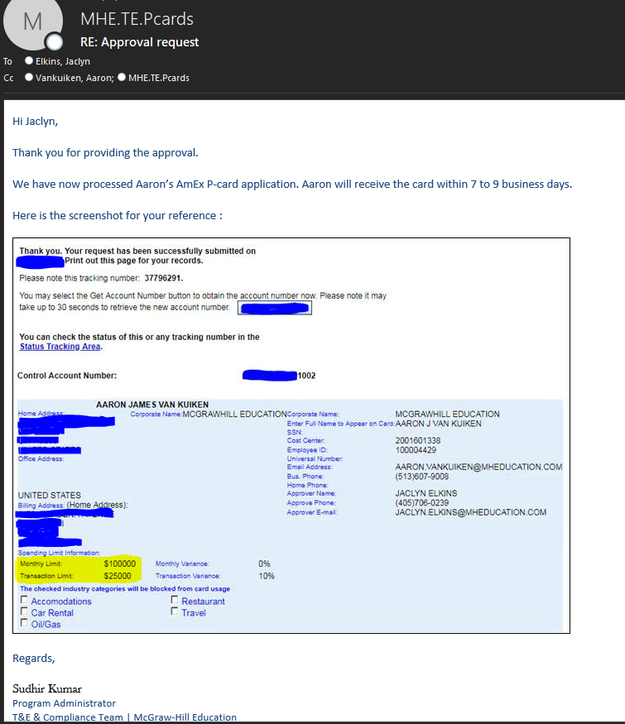

1. Compliance Control

* Employee ID
* SSN
* Card details
* Tracking number

1. Escalation Process

Genpact:

|  |  |  |  |  |
| --- | --- | --- | --- | --- |
| **S.No.** | **Issue** | **Name** | **Function** | **Phone** |
| 1 | Delay in deliverables on the planned date / Any other issue with the team | Syed Kamal | Process Supervisor | +919989227636 |
| 2 | Senthil Kumar Raja | Process Manager | +91 9100562602 |

McGraw Hill Education:

|  |  |  |  |  |
| --- | --- | --- | --- | --- |
| **S.No.** | **Issue** | **Name** | **Function** | **Phone** |
| 1 | Delay in deliverables on the planned date / Any other issue with the team | Raquel Carbonell | Travel Analyst.  FINANCE & OPERATIONS | +1 (609) 4699282 |
| 2 | Sheri Moore | Director, P2P Operations - GLOBAL PROCUREMENT & SOURCING | +1 (609) 469-9162 |

1. Contact details for T&E

T&E helpdesk – 866-703-4869

T&E voicemail box – 109 # * # - 7447803 (Mailbox no) – 4162 (Security code)

AmEx helpdesk for T&E – 888-800-8564

AmEx helpdesk for Employees – 800-528-2122

1. Process SLAs

|  |  |  |  |  |
| --- | --- | --- | --- | --- |
| **Indicator:** | **Name** | **Operational Definition** | **Target** | **Minimum Level** |
|  |  |  |  |  |
|  |  |  |  |  |

1. Sign Off.

[Please insert as object email from customer with sign off for the last revision of the SOP.]